
RAMAIAH
Institute of Technology
USN | 1 | M | S

(Autonomous Institute, Affiliated to VTU)
(Approved by AICTE, New Delhi & Govt. of Karnataka) Accredited by NBA & NAAC with ‘A’ Grade

EXAMINATIONS SEPTEMBER /OCTOBER 2020
SUPPLEMENTARY SEMESTER / GRADE IMPROVEMENT/ RE –REGISTERED CANDIDATES
Program | : | B.E.: Electrical and Electronics Engineering | Semester | : | V
Course Name | : | Control Systems | Max. Marks | : | 100
Course Code | : | EE52 | Duration | : | 3 Hrs

Instructions to the Candidates:
- Answer one full question from each unit.
- Suitably assume any missing data.

 |  | UNIT- I
1. | a) | What is the significance of presence of feedback in control system? Explain with at least two example. | CO1 | (06)
 | b) | Define transfer function? And Briefly explain the need for modeling of a system. | CO1 | (06)
 | c) | Obtain the transfer function 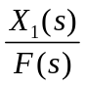 of the system shown in Fig.Q1.c where force f₁(t) is applied on mass M₁.  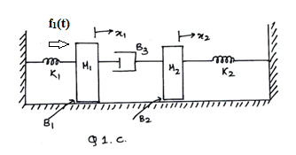 | CO1 | (08)
2. | a) | Obtain the transfer function of 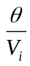 for the system shown in Fig.2a.  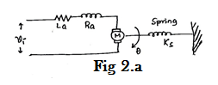 | CO1 | (10)
 | b) | Obtain the i) F-I Analogy ii) F-V analogy of the system shown in Fig.2b.  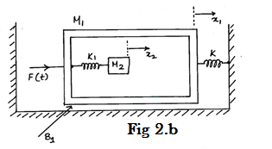 | CO1 | (10)
 |  | UNIT- II
3. | a) | Obtain the TF of the Block diagram shown in Fig.3a using SFG technique.  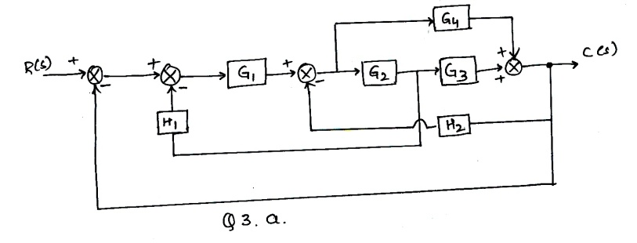 | CO1 | (08)
 | b) | Illustrate how to perform the following connection with block diagram reduction techniques:  - Moving a summing point behind a block and ahead a block.  - Moving a take-off point behind a block and ahead a block. | CO1 | (04)
 | c) | A second order system is represented by the transfer function, 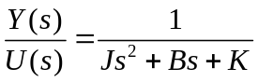. A step input of 10Nm is applied to system and results are,  - % 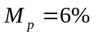  - 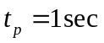  - The steady state value of output is 0.5 radians.  Find the values of J,B and K. | CO2 | (08)
4 | a) | A unity negative feedback system is characterized by OLTF 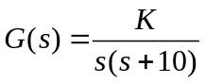. Find the value of K so that system will have damping ratio of 0.5. For this value of K determine settling time, peak overshoot and time to peak overshoot for unit step input. | CO2 | (08)
 | b) | The unit step response of the control system is as shown in Fig.Q4.b Find the transfer function of the prototype system used to model a second order system.  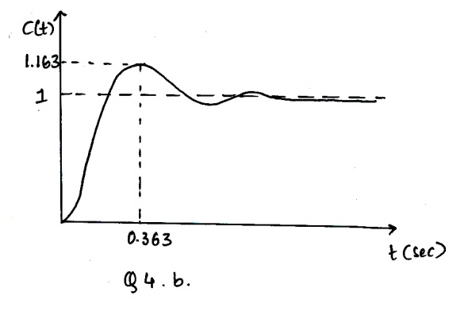 | CO2 | (06)
 | c) | Explain the meaning of Stable System. A closed loop TF is having zero at -2 and poles at -3, +5 is the system Stable? Justify with its time response behavior. | CO3 | (06)
 |  | UNIT- III
5. | a) | A negative unity feedback system is having OLTF  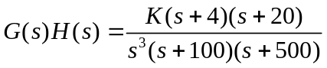  Find the range of K from RH criterion for which the system is stable. | CO3 | (08)
 | b) | A system having OLTF 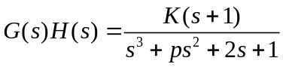, oscillates with frequency 2 rad/sec. Find values of ‘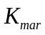’and ‘p’ if system is stable. | CO3 | (12)
6. | a) | Plot the root locus of the system with OLTF 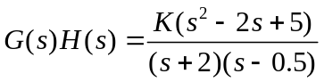. | CO3 | (10)
 | b) | The closed loop TF of positional control system is given by:  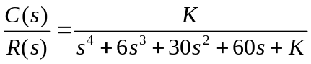.  Determine, i) The range of K for which system is stable.  ii) What should be the upper limit and lower limit of K if all the closed loop poles are required to be to the left of line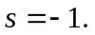 | CO3 | (10)
 |  | UNIT- IV
7. | a) | Define:  i) Resonant peak ii) Resonant frequency iii) Bandwidth iv) Cut off rate. | CO4 | (08)
 | b) | A unity negative feedback system is characterized by, 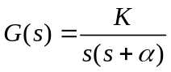.  Find the values of K and so that 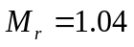and 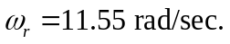  For these values of K and α, find the settling time and bandwidth of the system. | CO4 | (12)
8. | a) | Using Nyquist stability criterion, find the range of K for closed loop stability. The OLTF is given by 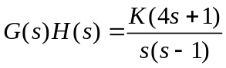. | CO4 | (10)
 | b) | A unit step input is applied to unity negative feedback system having OLTF 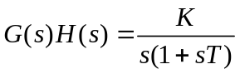.  Determine K and T to have peak overshoot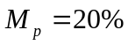 and resonant frequency 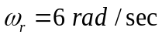. Also find resonant peak 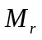 . | CO4 | (10)
 |  | UNIT- V
9. | a) | Obtain the transfer function of the system whose Bode plot is as shown in Fig. 9(a).  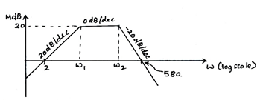  Fig. 9(a) | CO5 | (10)
 | b) | Define :  - Gain Margin  - Phase margin of a system. Hence mention the conditions for stability of a system. Also show the same using sample Nyquist plot. | CO5 | (10)
10. | a) | Obtain the transfer function of the system whose Bode plot is as shown in Fig. 10(a).  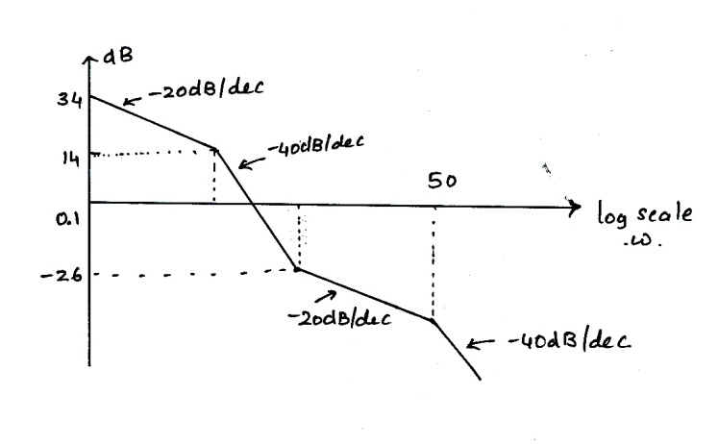  Fig. 10(a) | CO5 | (06)
 | b) | Obtain the transfer function of RC lead compensator, for 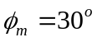and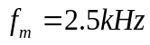. Assume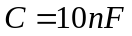. Also find the corner frequencies. Using vector diagram show that output waveform leads the input. | CO5 | (08)
 | c) | Explain the need for designing of a compensator with one practical example. | CO5 | (06)

****************

